**Business Problem:**

A multinational hotel Company which operates their hotel business in 175 countries. They have two type of hotel 1) City Hotel: - Hotel which located is within a city.

2) Resort Hotel: - Which is usually located near tourist point, beach, and hills

Hotel industry work on ***‘Booking-Waiting-Reservation and cancellation system’***. The more ***Booking-Waiting-Reservation*** will get more profit for hotels. And more the ***cancellation*** will be done more the losses for hotels because the room confirmed for that booking will not be able to assign to another booking. In recent days our client is getting more cancellation, so it effects their revenue. We need to find the reason for high cancellation rate and give some solutions to reduce it.



**Data collections:**

Our client gives their past 2-year data for analysis.

**Data Descriptions**

The data has been given by our client has 119390 raw and 32 columns.

Columns Name and their descriptions.

1. hotel :(H1 = Resort Hotel or H2 = City Hotel).
2. **Is cancelled** Value: showing if the booking had been cancelled (1) or not (0).
3. **Lead time**: Number of days that elapsed between the entering date of the booking into the PMS and the arrival date.
4. **Arrival date year**: Year of arrival date.
5. **arrival date month**: The months in which guests are coming.
6. **arrival date week number:** Week number of year for arrival date.
7. **arrival date day of month:** Which day of the months guest is arriving.
8. **stays in weekend nights**: Number of weekends stay at night (Saturday or Sunday) the guest stayed or booked to stay at the hotel.
9. **stays in week nights**: Number of weekdays stay at night (Monday to Friday) in the hotel.
10. **adults:** Number of adults.
11. **children:** Number of children.
12. **babies:** Number of babies.
13. **meal:** Type of meal booked.
14. **country:** Country of origin.
15. **market segment**: Through which channel hotels were booked.
16. **distribution channel:** Booking distribution channel.
17. **is repeated guest:** The values indicating if the booking name was from a repeated guest (1) or not (0).
18. **previous cancellations:** Show if the repeated guest has cancelled the booking before.
19. **previous bookings not cancelled:** Show if the repeated guest has not cancelled the booking before.
20. **reserved room type**: Code of room type reserved. Code is presented instead of designation for anonymity reasons.
21. **assigned room type:** Code for the type of room assigned to the booking. Code is presented instead of designation for anonymity reasons.
22. **booking changes:** How many times did booking changes happen.
23. **deposit type:** Indication on if the customer deposited something to confirm the booking.
24. **agent:** If the booking happens through agents or not.
25. **company:** If the booking happens through companies, the company ID that made the booking or responsible for paying the booking.
26. **days in waiting list:** Number of days the booking was on the waiting list before the confirmation to the customer.
27. **customer type:** Booking type like Transient – Transient-Party – Contract – Group.
28. **adr**: Average Daily Rates that described via way of means of dividing the sum of all accommodations transactions using entire numbers of staying nights.
29. **required car parking spaces:** How many parking areas are necessary for the customers.
30. **total of special requests:** Total unique requests from consumers.
31. **reservation status:** The last status of reservation, assuming one of three categories: Cancelled – booking was cancelled by the customer; Check-Out.
32. **reservation status date:** The last status date.

**Assumptions:**

* 1. No unusual occurrences between 2015 and 2017 will have a substantial impact on

the data used.

* 1. The information is still current and can be used to analyse a hotel's possible plans in

an efficient manner.

* 1. There are no unanticipated negatives to the hotel employing any advised technique.
  2. The hotels are not currently using any of the suggested solutions.
  3. The biggest factor affecting the effectiveness of earning income is booking cancellation.
  4. Cancellation result in vacant rooms for the booked length of time
  5. Clients make hotel reservations the same year they make cancellation.
  6. The suggestion is given by the analysis is not use currently.

**Research Question**

1. What are those variables those affect hotel reservation cancellations?
2. How can we reduce hotel reservations cancellations rate?
3. How will hotels be assisted in making pricing and promotional decisions?

**Hypothesis**

1. cancellation depends on Hotel Type.
2. Days in waiting list influences cancellation rate.
3. cancellation rate is dependent on meal.
4. cancellation is any country specific.
5. Price is affecting the cancellation rate for Portugal.
6. Cancellation is depended in deposit type.
7. Cancellation rate is depended on customer type.
8. Cancellation rate is depended on Market Segment.

**Data Processing and Cleaning:**

Raw data giving by our client is not ready to use it need to clean and process in such a way that it will be used for analysis.

* + 1. Converting ‘reservation status date’ to proper format
    2. ‘company’, ‘agent’ has 112593 and 16340 no of missing value so I dropped those columns.
    3. ‘country’ has 488 null values, so I dropped those raw
    4. “Booking changes”, “ADR”, “days in waiting list”, have some outlier I handled those outliers.

**Data lost during data processing and cleaning.**

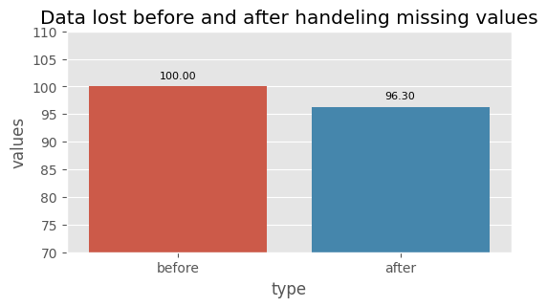

**Hypothesis Testing:**

1. **Cancellation depends on Hotel Type.**

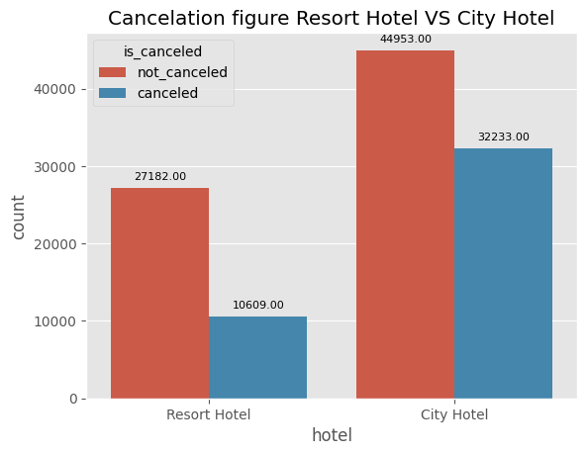

From the above graps the hypothesis proved right. City hotel have morecancellation than resort hotel. For proper analysis we need to find out the reason

From the above graphs we can conclude that our hypothesis is correct. Price has positive effect on cancellation rate because city hotel have higher price and higher cancellation rate throughout the year except summer season(“JUN,JULY,AUG,SEPT) this time average price rate is for resort hotel is relatively high.

**Suggestions: -** Hotel ADR price can be reduced to some extend and increase to lower cancellation rate. And resort value ADR can be increase during ‘SEPT’,’NOV’ To recover loses which getting by reduce Hotel ADR price.

1. **Days in waiting list influences cancellation rate.**

Hypothesis proved wrong here because only ‘0’ waiting days cover 99.91 percent of data further analysis is impossible here.

1. **Cancellation rate is dependent on meal.**

From the above graph our hypothesis “Cancellation dependency on meal” is proved right.

Here we can see that ‘HB’ have the lowest rate of cancellation and ‘FB’ have highest rate of cancellation.

**Suggestions: -** All other meal type can be converted to ‘HB’ to reduce cancellation rate.

1. **cancellation is any country specific.**

Our hypothesis proved right here Cancellation rate is depended on country.

Portugal has severe rate of cancellations Before coming to any conclusion need to find the cause for higher rate of cancellations in PRT country.

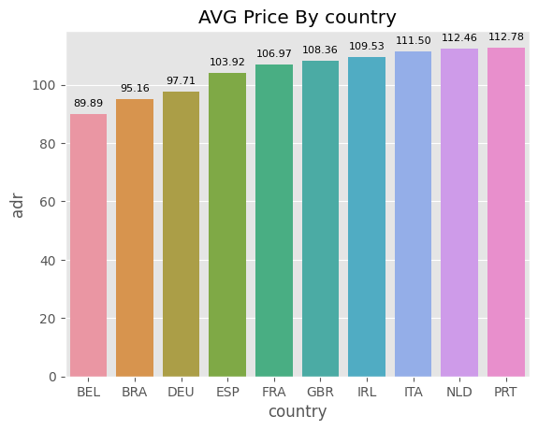

From the above graph it can be concluded that Price is one of the factors for increasing PRT cancellation rate severely. But their may be some other reason too which cannot be determine by this data set.

**Suggestions: -** Average ‘ADR’ price for Portugal can be reduce to some extend to decrease cancellation rate.

1. **Cancellation is depended in deposit type.**

From the above graph it can be concluded that our hypothesis is proved right here. Cancellation rate depends on deposit type. Refundable deposit type has the lowest rate of cancellation.

**Suggestions: -** Try to convert most of the booking refundable to reduce cancellation rate.

1. **Cancellation rate is depended on customer type.**

From the above graphs we can conclude that our hypothesis is right. Cancellation rate is depended on customer type.

Transient customer has most no of records and more trend to do cancellation.

**Suggestions: -** Give special attention to the transient customer May be some offer is given to resist them from cancellation.

1. **Cancelation rate is depended on Market Segment.**

From the graphs we can conclude our hypothesis is proved right here cancellation is depended on market segment. Complimentary and aviation record is very less with compared to others so we will not consider those segments. From the rest segments Groups have severe rate of cancellations and Offline TA/TO, Online TA have also relatively high cancelation rate.

**Suggestions**: - Give some offer and facility to this segment customer to reduce cancellation rate.

**Summary of findings:**

From the above analysis we have finds some insight that are given below.

1. Price has positive effect on cancellation rate because city hotel has higher price and higher cancellation rate throughout the year except summer season (JUN, JULY, AUG, SEPT) this time average price rate is for resort hotel is relatively high.
2. Cancellation rate doesn’t depend on “Days waiting list” time span because 99.98% of the records have only one single value.
3. There is a dependency of cancellation rate on “meal”. HB – 34.52%, SC-37.40%, BB-37.44%, FB-62.55% Cancelations rate.
4. Cancellation rate varies by country to country. Portugal has severe rate of cancellations because of average ADR rate in Portugal is high compared to others.
5. Deposit type of booking has an influence on the cancellations rate. Refundable booking type has the lowest rate of cancellation.
6. Cancellation rate is depended on customer type. Transient customer has most no of records and more trend to do cancellation.
7. Complimentary and aviation record is very less with compared to others so we will not consider those segments. From the rest segments Groups have severe rate of cancellations and Offline TA/TO, Online TA have also relatively high cancelation rate.

**Strategy: -**

1. Offer promotions or discounts during the off-season to attract more guests to the city hotel.
2. Since the "Days waiting list" time span doesn't affect the cancellation rate, you can focus on other factors that influence cancellation, such as price and deposit type.
3. Consider revising the meal plans offered to guests, particularly for those who choose full-board packages, as these have a higher cancellation rate.
4. Develop targeted marketing strategies to attract guests from countries with lower cancellation rates, such as those with a lower average ADR rate.
5. Encourage guests to choose refundable booking types by offering more flexible booking policies.
6. Develop personalized marketing strategies for different customer segments, especially for transient customers who are more likely to cancel their bookings.
7. Consider providing incentives to offline travel agents and tour operators to encourage them to promote your hotel to their customers.

Top of Form

**Conclusion: -**

By implementing these strategies, we expect to reduce the cancellation rate, increase occupancy rates, and ultimately improve the company's profitability. It is important to continuously monitor and evaluate the effectiveness of these strategies and adjust them accordingly to ensure their success.

Along with this strategy company need to focus to improve guest servicing experience and organise some event to make memorable of guest moment.